Shanghai Goodview Electronics Technology Co. Ltd.

75 inch Commercial LCD Monitor
Model:M75STL

Revision History
Part number | Version | Publish date | Written by | Auditing | approval | Remarks
1374601 | GV-M75STL-GGS20180109 | 2018\1\9 |  |  | 
Note：All right reserved by Goodview.Please contact with us for the latest updates.

Product Specifications
Display
Panel |  | 75 inches LED backlight
Active Area (mm) |  | 928.26（H）×1650.24（V）
Aspect Ratio |  | 16:9
Resolution |  | 3840×2160
Brightness |  | 430 cd/m2
Contrast Ratio |  | 1000:1
Viewing Angle (CR>10) |  | All view angle ( R/L 89 (Min.), U/D 89 (Min.))
Display Colors |  | 10bit, 1.07 Billion
Color temperature |  | TBD
Back light bulb Life |  | 30000 hours
Response time |  | 8ms
System configuration
Operating system |  | Android 5.0.1
CPU |  | ARM A53×4 1.4GHz
GPU |  | ARM Mali450 MP4(4+2) 450MHz
Memory |  | 2G
Storage |  | 16G
Touch
Touch type |  | Infrared touch
Touch Points |  | 20 points
Interpolation resolution |  | 32767×32767
Touch accuracy |  | ±2mm(More than 90% of the touch area)
Response time |  | <15ms
Enter mode |  | Finger, stylus, opaque objects
Smallest touch objects | Single | 6mm
Smallest touch objects | Multipoint | 8mm
External ports
Signal ports |  | HDMI(1.3) IN×2  VGA IN×1  VGA Audio IN×1  DP IN×1  AV ×1  YPBPR×1  AV OUT×1  Audio OUT×1
Network ports |  | Wired network: LAN×1（RJ45 10/100M Ethernet）  wireless network: WiFi×1（802.11bgn）
Storage extension |  | Micro SD Card ×1
Other ports |  | AC Switch×1  AC IN×1  USB 3.0 IN×2  Touch OUT USB（TypeB）×1  IR IN×1 (3.5mm JACK)  RS232×1 (DB9)  SPDIF×1
Multimedia
picture |  | File extension name | *.jpg, *.bmp, *.png
 |  | The encoder | Standard RGB
 |  | Maximum image resolution | Baseline :  JPG : 6000 x 6000  GIF : 1920 x 1080  BMP : 1920 x 1080  PNG : 1920 x 1
 |  | Maximum filename length | 128 bytes
video |  | File extension name | *.mpg, *.avi, *.mp4, *.mkv, *flv, *.mov, , *.ts,
 |  | Coding and code rate | MPEG-1 bitrate<20Mbps  MPEG-2 bitrate<40Mbps  MPEG-4 bitrate<30Mbps  H.264 bitrate<30Mbps  AVC bitrate<30Mbps  H263 bitrate<30Mbps  XVID bitrate<30Mbps
audio |  | File extension name | *.mp3,AAC, wav
 |  | The encoder | MPEG Audio, PCM
text |  | File extension name | *.txt
 |  | Encoder format | ANSI、
Play mode |  | Horizontal screen, Vertical screen, full screen and split screen play
Program transmission mode |  | USB、LAN、Wan
Other parameters
Product size (mm) |  | 1045.23(H)×1767.16(V)×98.8(D)
Package size（mm） |  | 1351（H）×2051（V）×394（D）
VESA（mm） |  | 400×600 （Screw type M8×25mm）
Screen hanging mode |  | landscape、portrait
Menu language |  | Chinese、English
Machine color |  | black
Weight |  | net：54KG (TBD) |  | gross：69KG (TBD)
Power Consumption |  | 260W (Max)
Speaker |  | stereo 2×10W 8Ω
Smart volume |  | time-sharing volume
Watchdog |  | N/A
Timing function |  | Multi-time timing power on/off, port timing automatic switch
Management software |  | GTV Information Distribution System
Power supply |  | AC~100-240V (50/60Hz ± 3 Hz )
Working environment |  | 0〜40℃ 10% 〜 85%RH No condensation
Storage environment |  | -10〜60℃ 10% 〜 75%RH No condensation
Accessories |  | 1. Warranty card * 1.  2. Certificate of qualification  3. Quick start guide x 1.  4. AC power line x 1 (national standard)  5. 2.4G WiFi antenna x 1 root.  6. Remote control * 1.  7. AAA battery x 2Pcs.  8.Safety and environmental considerations *1
Certificates |  | /

Schematic Drawing
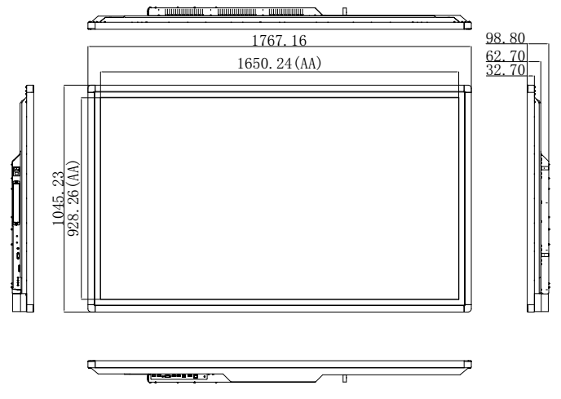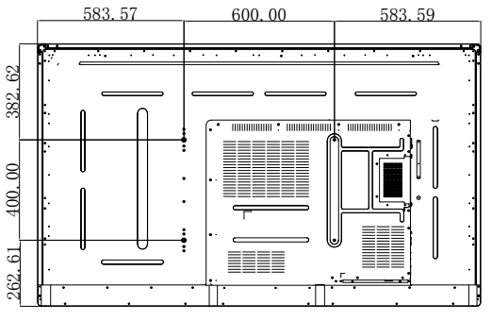

Product Images
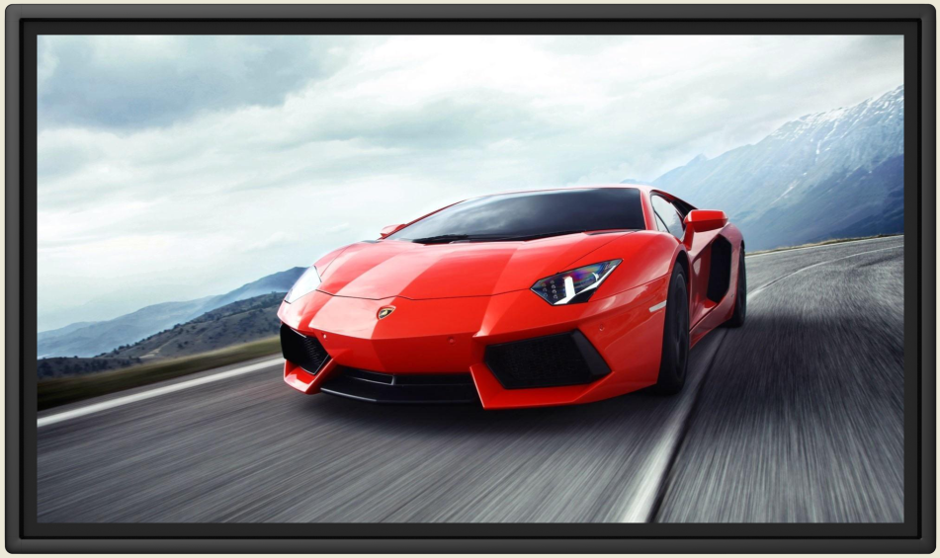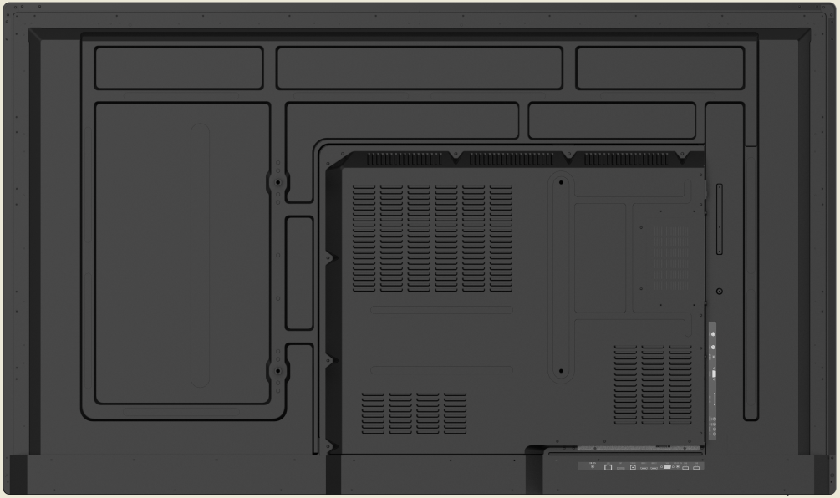

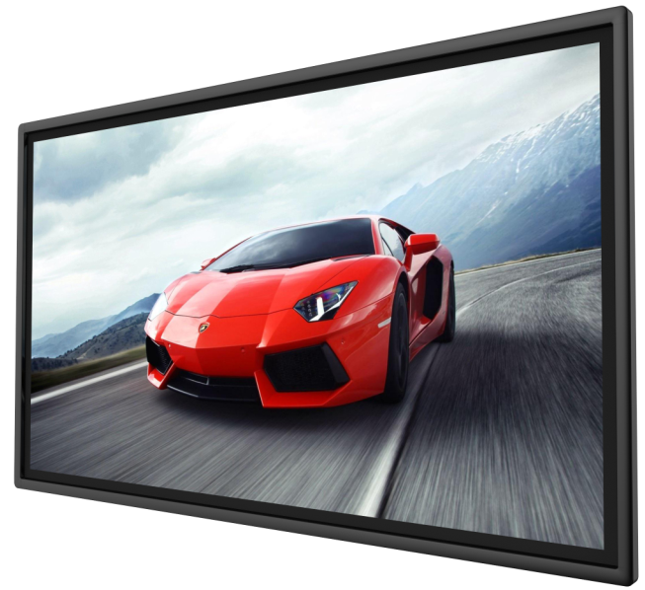
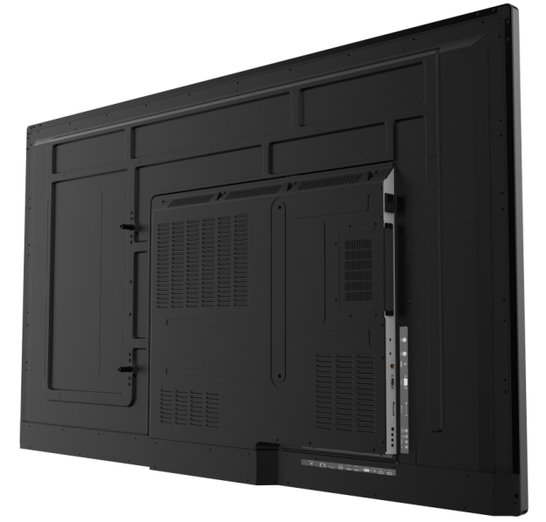


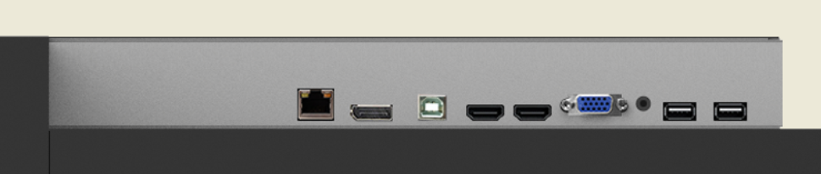
AC IN
AC SW
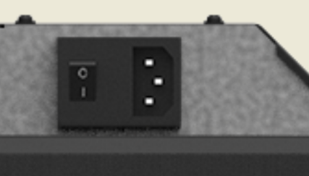
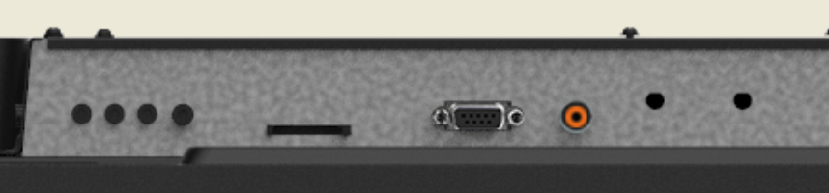

Packaging
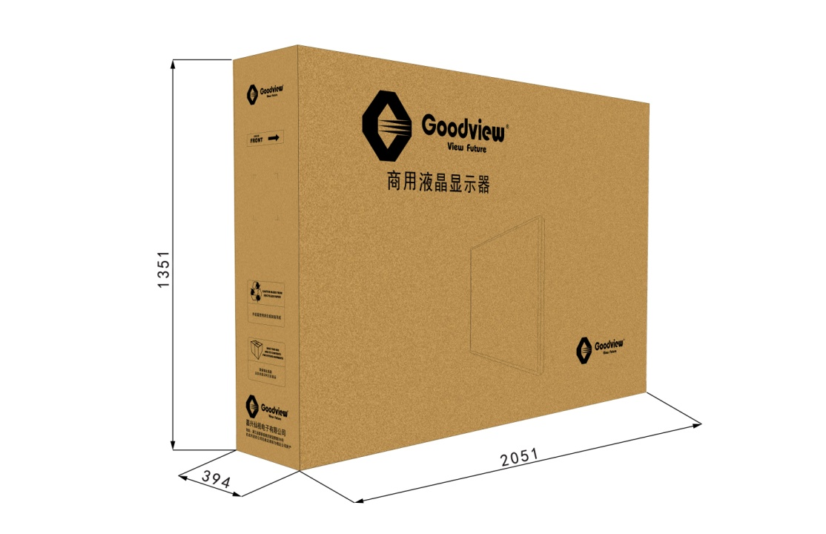
unit：mm
Note：All right reserved by Goodview.Please contact with us for the latest updates.

