Shanghai Goodview Electronics Technology Co. Ltd.

75 inch Commercial LCD Monitor
Model:M75SAL

Revision History
Part number | Version | Publish date | Written by | Auditing | approval | Remarks
1158501 | GV-M75SAL-GGS20180108 | 2018\1\8 |  |  | 

Note：All right reserved by Goodview.Please contact with us for the latest updates.

Product Specifications
Display
Panel | 75 inches LED backlight
Active Area (mm) | 928.26（H）×1650.24（V）
Aspect Ratio | 16:9
Resolution | 3840×2160
Brightness | 430 cd/m2
Contrast Ratio | 1000:1
Viewing Angle (CR>10) | All view angle ( R/L 89 (Min.), U/D 89 (Min.))
Display Colors | 10bit, 1.07 Billion
Color temperature | TBD
Back light bulb Life | 30000 hours
Response time | 8ms
System configuration
Operating system | Android 5.0.1
CPU | ARM A53×4 1.4GHz
GPU | ARM Mali450 MP4(4+2) 450MHz
Memory | 2G
Storage | 16G
External ports
Signal ports | HDMI(1.3) IN×2  VGA IN×1  VGA Audio IN×1  DP IN×1  AV ×1  YPBPR×1  AV OUT×1  Audio OUT×1
Network ports | Wired network: LAN×1（RJ45 10/100M Ethernet）  wireless network: WiFi×1（802.11bgn）
Storage extension | Micro SD Card ×1
Other ports | AC Switch×1  AC IN×1  USB 3.0 IN×2  Touch OUT USB（TypeB）×1  IR IN×1 (3.5mm JACK)  RS232×1 (DB9)  SPDIF×1
Multimedia
picture | File extension name | *.jpg, *.bmp, *.png
picture | The encoder | Standard RGB
picture | Maximum image resolution | Baseline :  JPG : 6000 x 6000  GIF : 1920 x 1080  BMP : 1920 x 1080  PNG : 1920 x 1
picture | Maximum filename length | 128 bytes
video | File extension name | *.mpg, *.avi, *.mp4, *.mkv, *flv, *.mov, , *.ts,
video | Coding and code rate | MPEG-1 bitrate<20Mbps  MPEG-2 bitrate<40Mbps  MPEG-4 bitrate<30Mbps  H.264 bitrate<30Mbps  AVC bitrate<30Mbps  H263 bitrate<30Mbps  XVID bitrate<30Mbps
audio | File extension name | *.mp3,AAC, wav
audio | The encoder | MPEG Audio, PCM
text | File extension name | *.txt
text | Encoder format | ANSI、
Play mode | Horizontal screen, Vertical screen, full screen and split screen play
Program transmission mode | USB、LAN、Wan
Other parameters
Product size (mm) | 1045.23(H)×1767.16(V)×98.8(D)
Package size（mm） | 1351（H）×2051（V）×394（D）
VESA（mm） | 400×600 （Screw type M8×25mm）
Screen hanging mode | landscape、portrait
Menu language | Chinese、English
Machine color | black
Weight | net：54KG (TBD) |  | gross：69KG (TBD)
Power Consumption | 260W (Max)
Speaker | stereo 2×10W 8Ω
Smart volume | time-sharing volume
Watchdog | N/A
Timing function | Multi-time timing power on/off, port timing automatic switch
Management software | GTV Information Distribution System
Power supply | AC~100-240V (50/60Hz ± 3 Hz )
Working environment | 0〜40℃ 10% 〜 85%RH No condensation
Storage environment | -10〜60℃ 10% 〜 75%RH No condensation
Accessories | 1. Warranty card * 1.  2. Certificate of qualification  3. Quick start guide x 1.  4. AC power line x 1 (national standard)  5. 2.4G WiFi antenna x 1 root.  6. Remote control * 1.  7. AAA battery x 2Pcs.  8.Safety and environmental considerations *1.
Certificates | /

Schematic Drawing
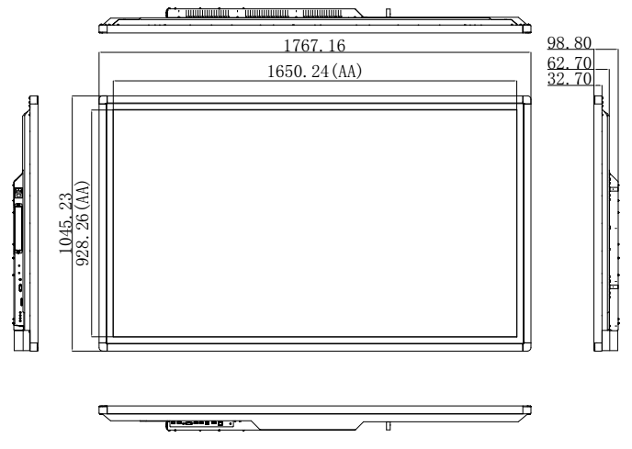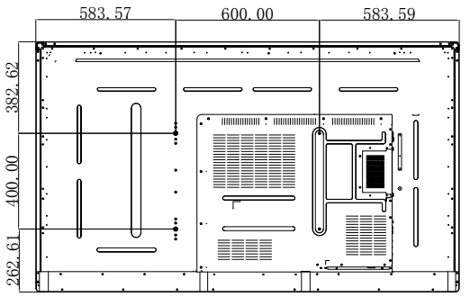

Product Images

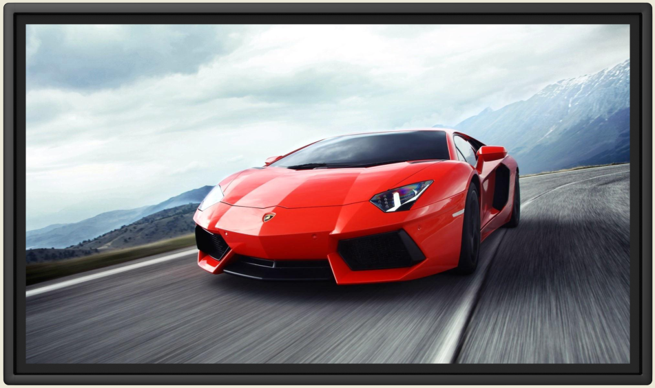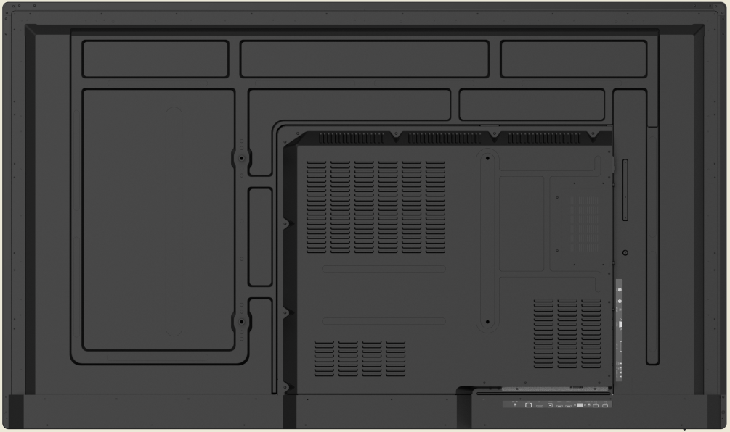

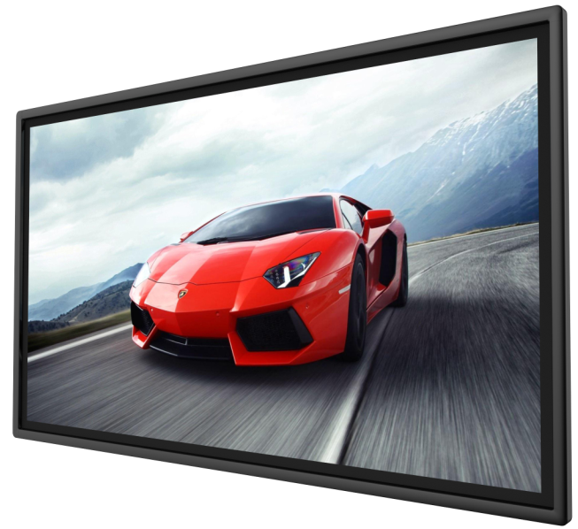
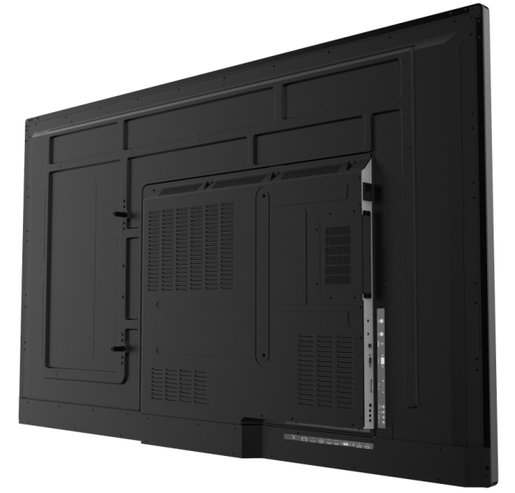


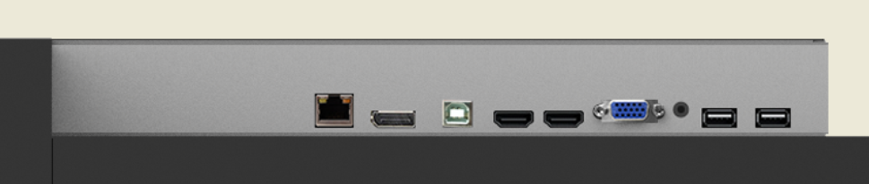
AC IN
AC SW
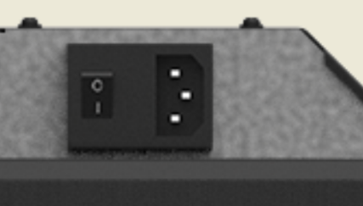
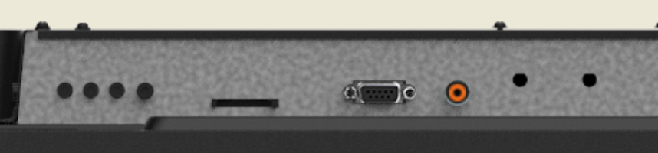

Packaging
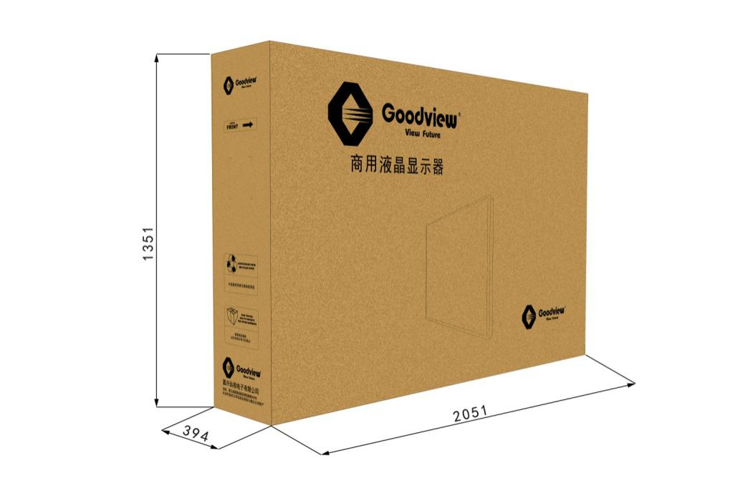
unit：mm
Note：All right reserved by Goodview.Please contact with us for the latest updates.

